**Task No. 1:** Create a visiting card using MS publisher.

**Solution:**

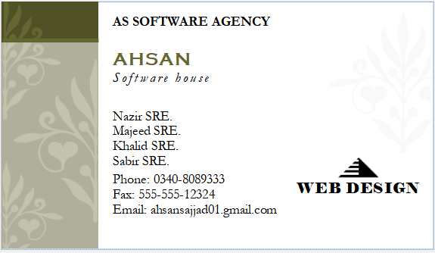

**Task No. 2:** Create your own CV using MS publisher.

**Solution:**

#### 

**Task No. 3:** Create a Sloucher using MS publisher.

**Solution:**

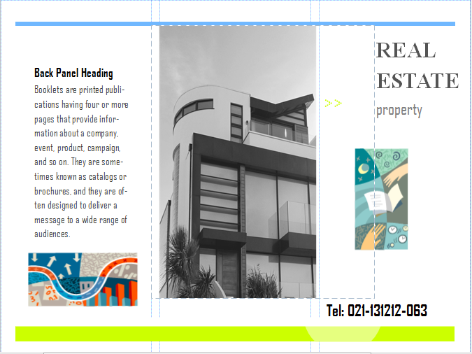

**TEL: 021-1323-01**

